February 2024 News Update

Autism Services Guide
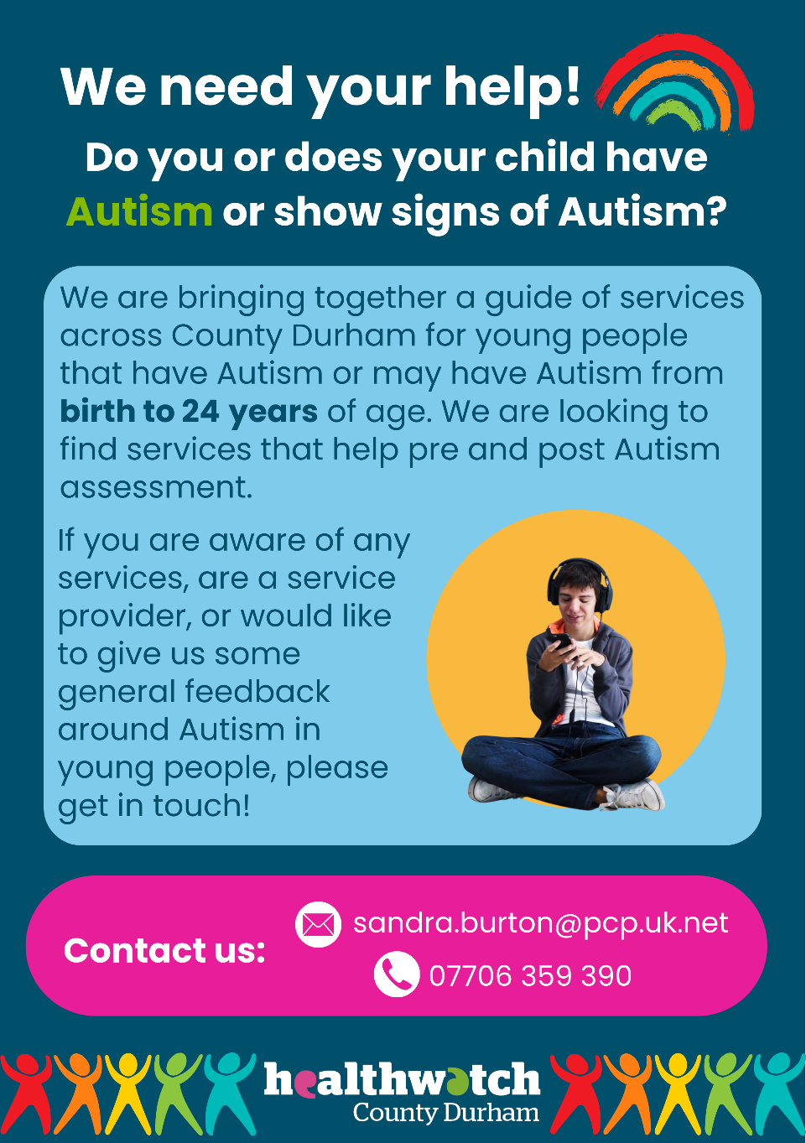
Do you or does your child have Autism?
We are putting together a guide of services that offer support both pre and post autism diagnosis to help people in County Durham. Our guide could take the pressure off people struggling to find where to turn.
Get in touch:
07706 359390
sandra.burton@pcp.uk.net

Time to Talk Day
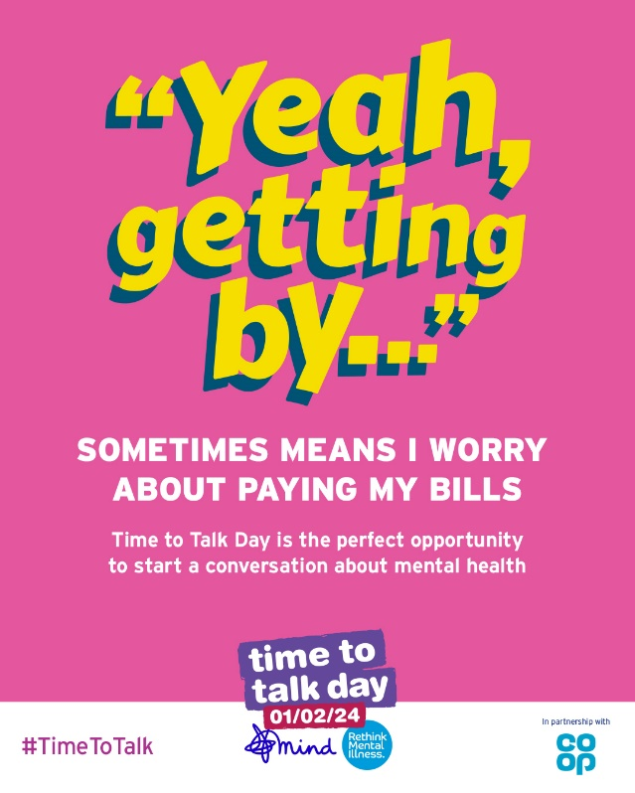
Time to talk day was 1st February.
We encourage people to continue the conversation and come together to talk about how they are really feeling. Sometimes people will say they are 'not too bad' when they feel lost or alone.
Time to Talk Day should be every day, so remember to check in on friends/family and colleagues to ask how they are doing. And remember if you are struggling its okay, reach out to people you can trust.

Inclusion Update
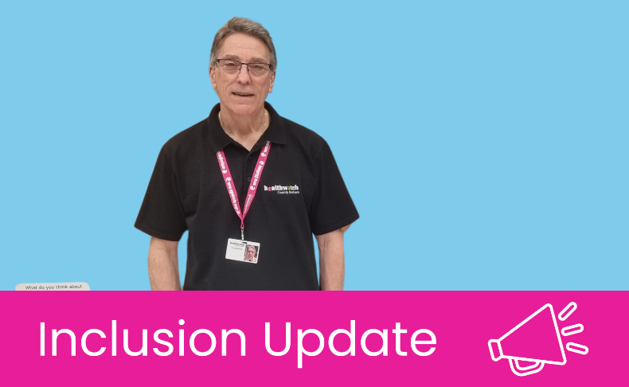
Reasonable Adjustments
One element of the Healthwatch Inclusion role has been looking at where reasonable adjustments are needed for different social groups, and raising awareness of what should be available, and how to ask. We are contributing to the work the North East and North Cumbria Learning Disability Network and the NHS are doing in our region to raise awareness about reasonable adjustments.
Making reasonable adjustments means that (under the Equality Act 2010) businesses, including the NHS, must make it as easy for disabled people to use their services as it is for people who are not disabled.
People with a physical disability, sensory disability, learning disability or long-term condition such as dementia are entitled to ask for a reasonable adjustment to remove barriers to using health & care services. For example, in the NHS, this could mean:
- Providing information in an easy read format.
- Installing a ramp
- Providing a longer appointment time.
- Providing a quiet room in which people may wait.
Reasonable adjustments are individual and should be tailored to the person, so it’s really important to tell your health and care professionals the reasonable adjustments you or the person you care for need.
Please visit below for more information:
Web - www.necldnetwork.co.uk/work-programmes/reasonableadjustments
X - @necldnetwork
Email - England.learningdisabilitynetwork@nhs.net
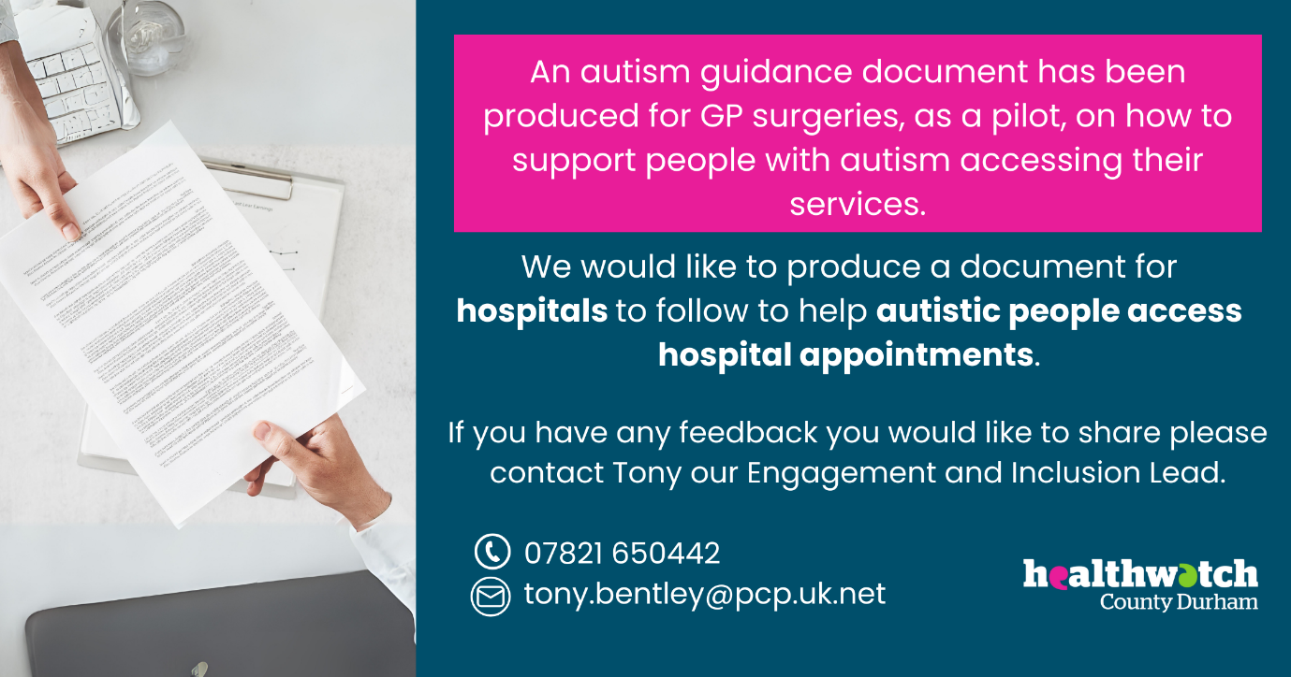

Crisis Listening Service Change of Number
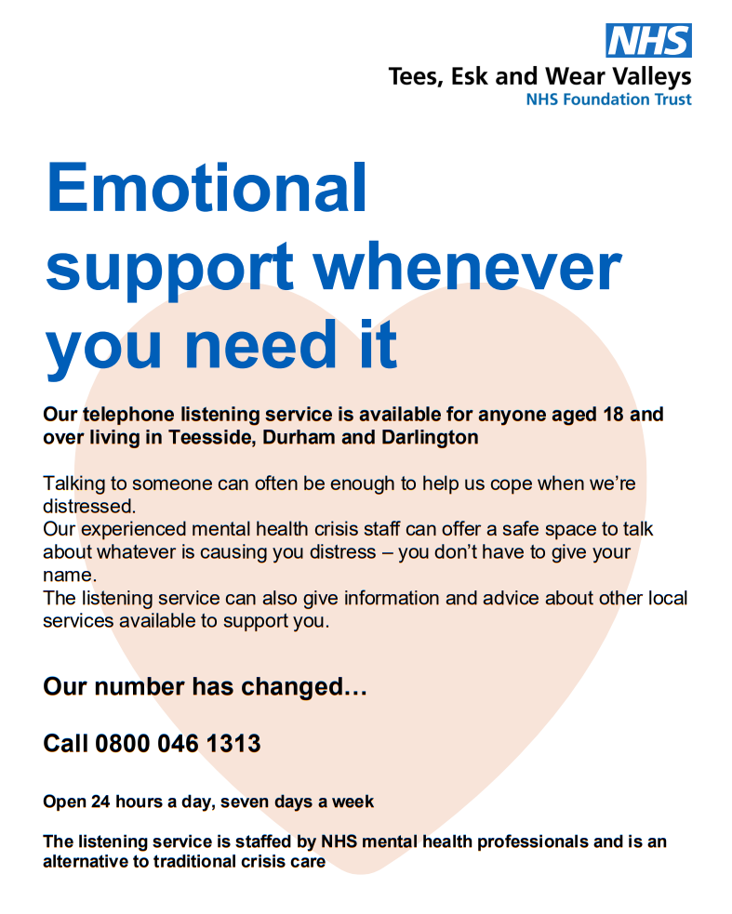
The new number for Durham Tees Valley listening service has now switched to freephone 0800 046 1313.
The listening service has been sharing its phone number with our crisis line. It will be switching to a dedicated 0800 number as the crisis line prepares to transfer to NHS 111 select mental health option, very soon.
The team will continue to offer 24/7 emotional support and advice to anyone aged 18 and over living in Teesside, Durham and Darlington.
Anyone who rings the existing listening service number will be automatically re-routed, so they can still access the support they need.

Enter and View Review

We recently tasked two of our Healthwatch County Durham volunteers with contacting two Care Homes, Rose Lodge nursing home and Devonshire House nursing home. We had previously visited these care homes, as part of our ‘Enter & View programme’, pre Covid. We revisited what the reports had told us from our visits about what was highlighted as important and valuable for the residents we spoke to, at the time of the visit. We were interested to see if those elements had been retained, improved or had encouraged any new initiatives to meet needs and whether the Enter & View visit had resulted in positive change.
Read below to find out about the changes and feedback.
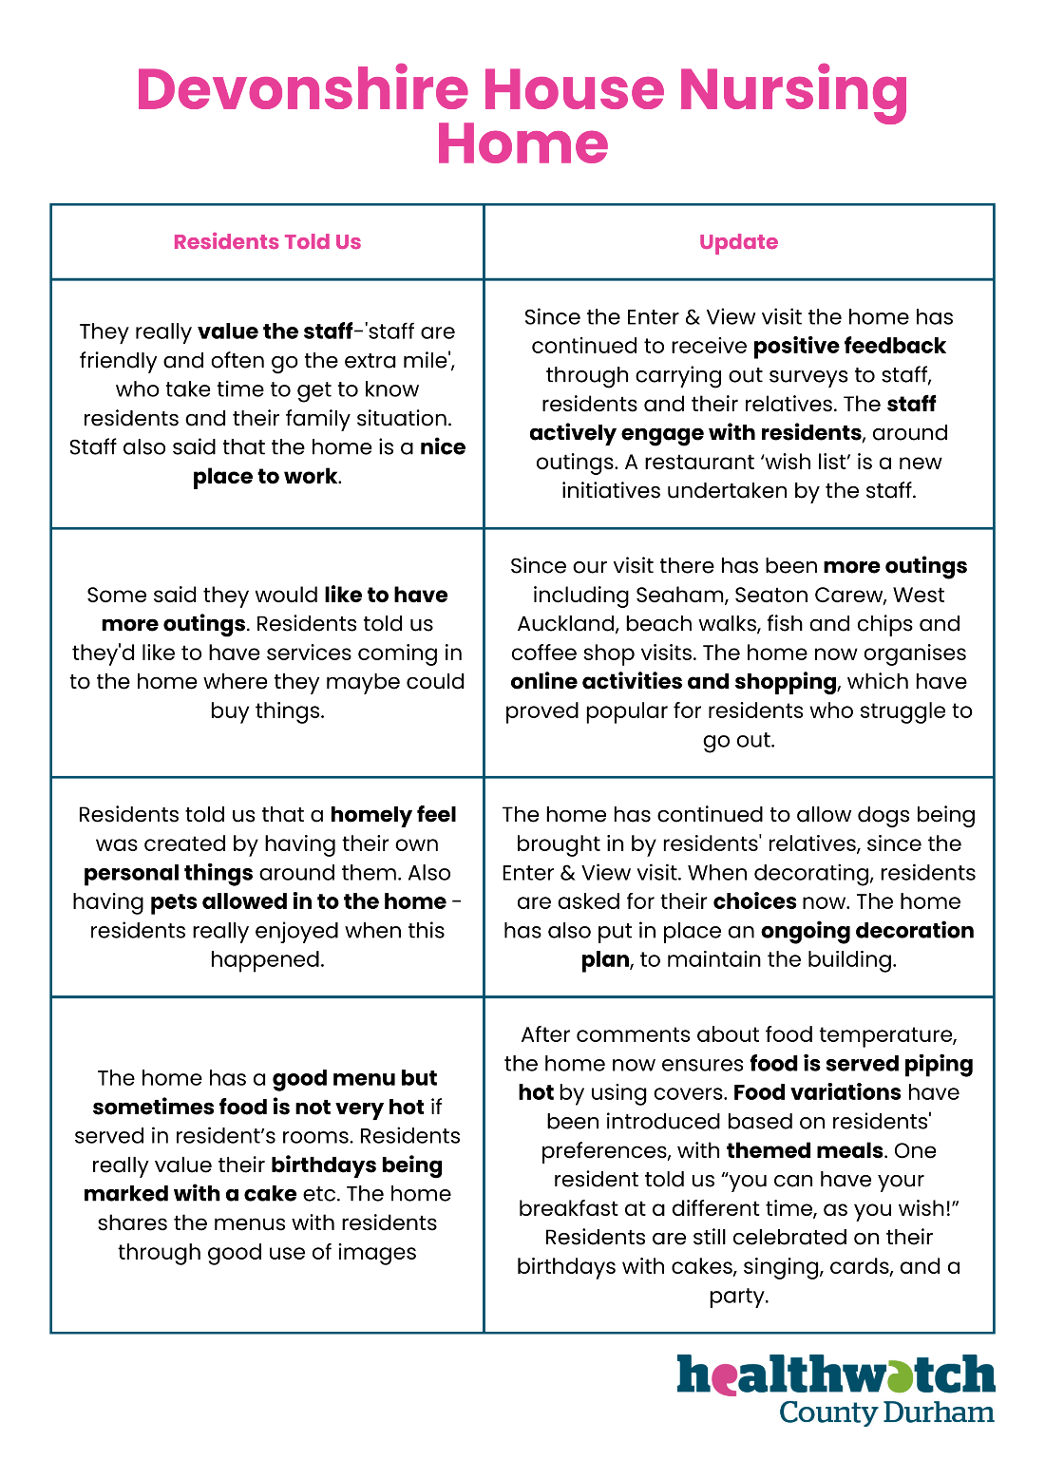

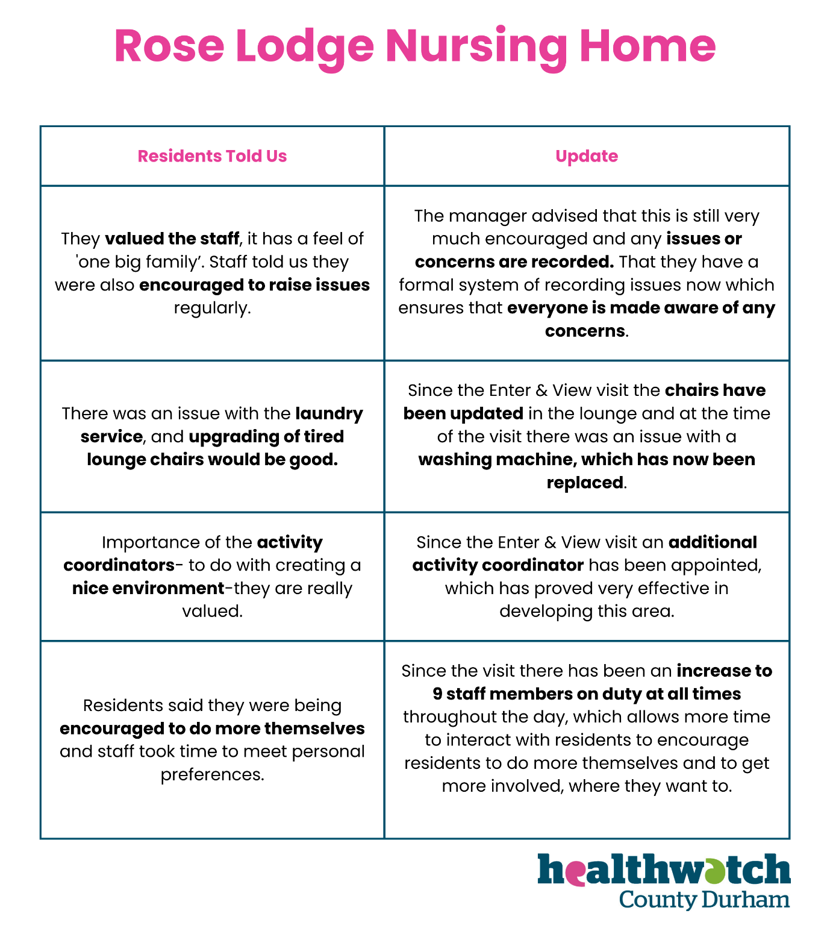

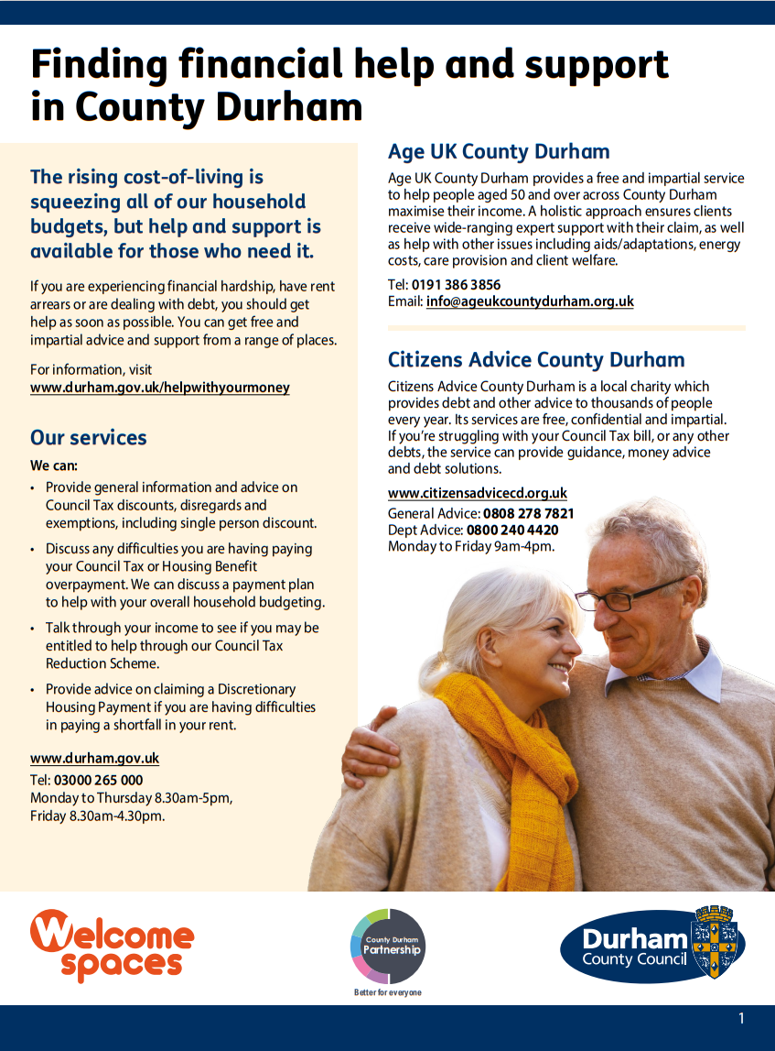
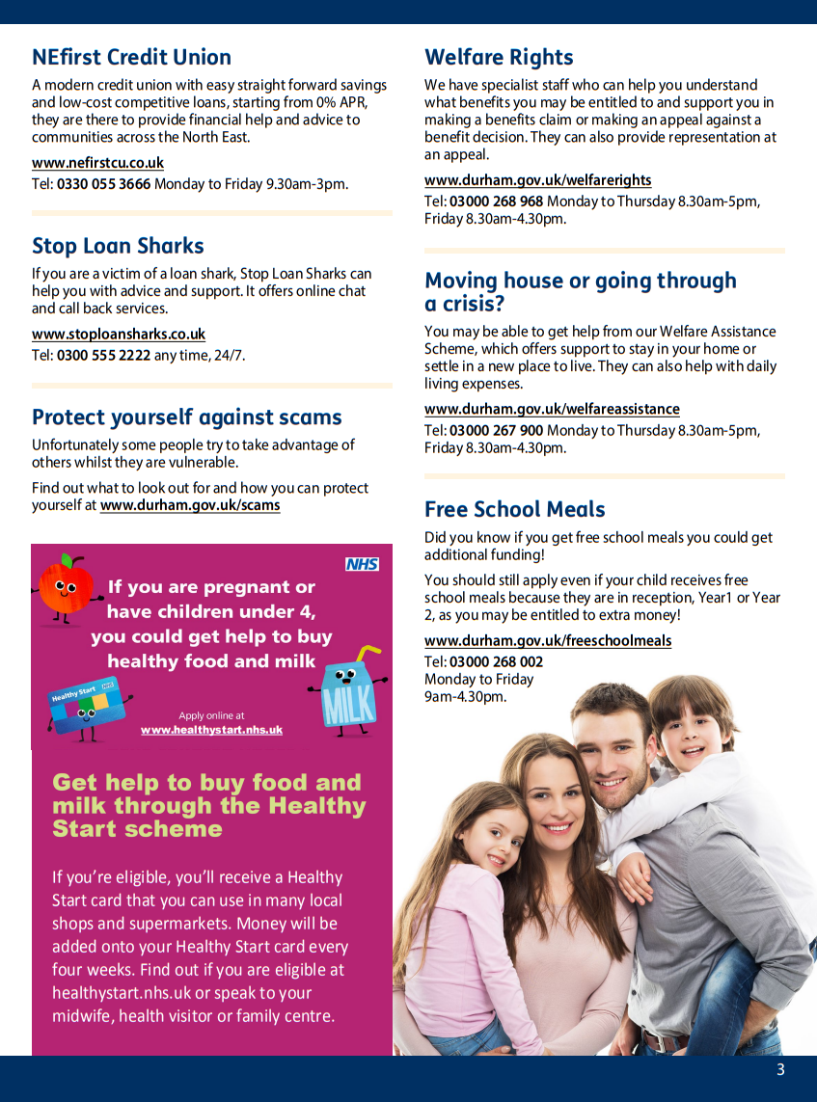
Financial Help in County Durham
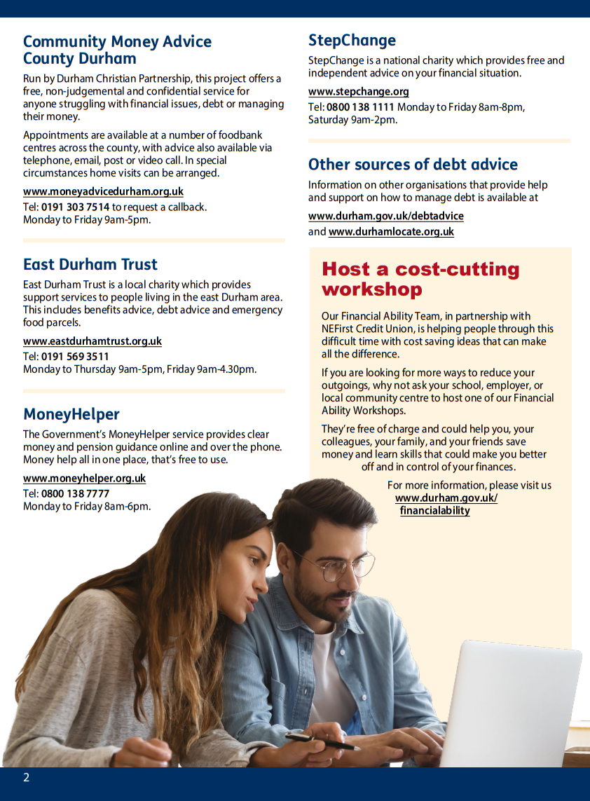
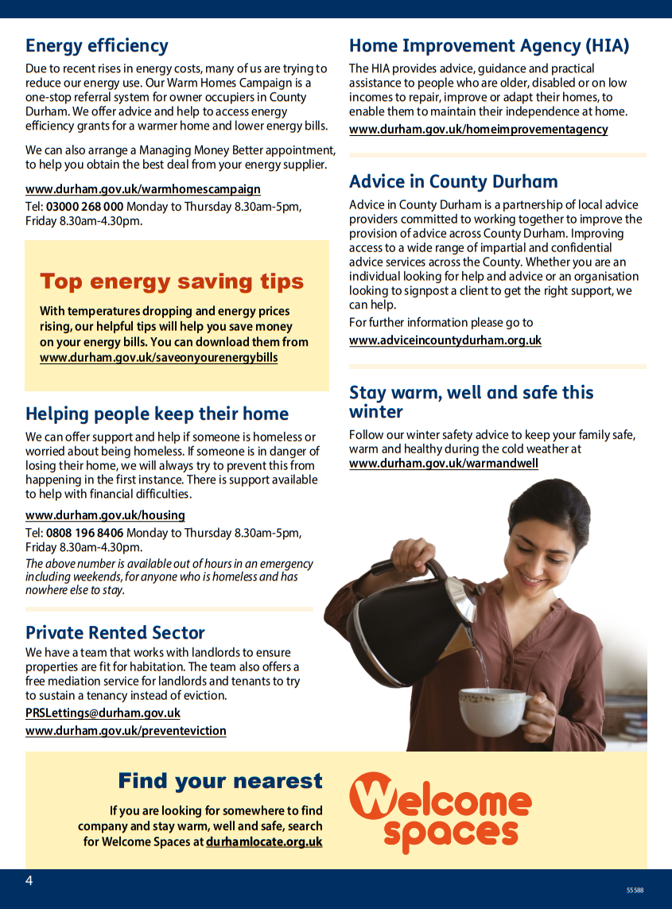

Become a Community Champion
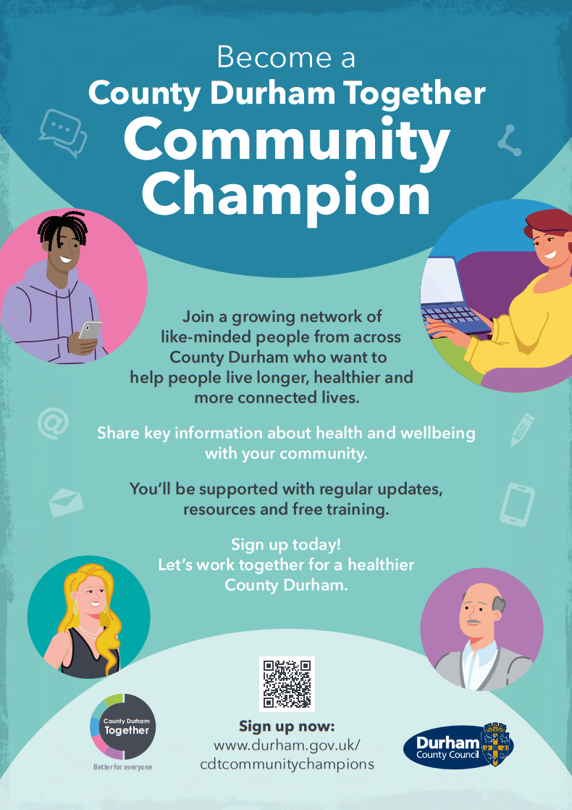

Could you be a County Durham Together Community Champion?
Do you see and talk to people in your community on a regular basis?
Maybe you’re part of a group, club or sports team, or perhaps you just enjoy meeting people and having a chat.
If this sounds like you, and you have an interest in health and wellbeing, then you could become a Community Champion.
You'll play a part in helping people live longer, healthier and happier lives, by making sure our communities get the best public health information.
You don't need to have any experience or know about health already, just an interest in knowing more and a willingness to share what you learn.
You’ll be supported with regular updates from Public Health, resources and free training.
It's then up to you how you share that information with your friends, family, people you know and your community.
Sign up today to become a County Durham Together Community Champion and let’s work together for a healthier County Durham.
Find out more at www.durham.gov.uk/cdtcommunitychampions

Early Learning and Development – Start for Life
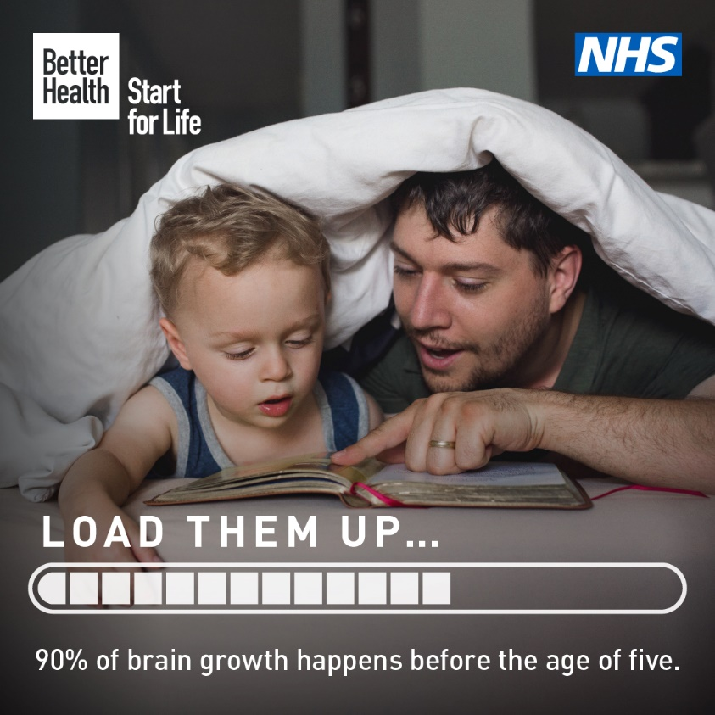
Encouraging your child’s natural curiosity is one of the many ways to boost their brain development. Discover more, everyday things you can do at Start for Life.
Click here to find out more by searching NHS Early Learning and Development.

Gambling Survey
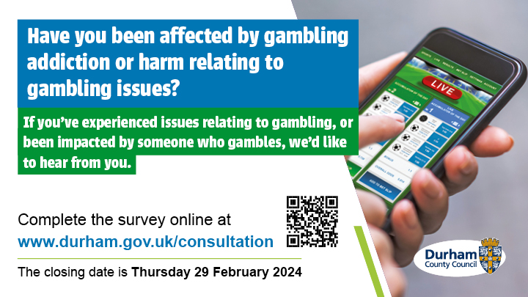
Durham County Council are carrying out a survey to help them assess the health needs of people living in County Durham who are:
- gambling addicts
- at risk of becoming addicted
- friends and family impacted by the gambling habits of a loved one
This is called a Gambling Health Needs Assessment and it means identifying people's healthcare needs, gaps in support, and what changes are required to fill those gaps.
As part of this health needs assessment, Durham County Council would like the views from health services professionals regarding their understanding of gambling addiction, the related harms and how they feel about providing support for those effected. They would also like to know your thoughts how they can provide information to support professionals to provide help for those worried about gambling.
To complete the survey please click here: https://forms.office.com/e/qXFeqXWaZu

The Big Royal National Institute of Deaf People Survey
If you’re deaf or have hearing loss, please tell us what it's like living in the UK today by taking part in our survey (closing on Monday 26 February 2024).
RNID want to learn what assumptions, challenges and misconceptions you might face on a day-to-day basis to help us understand what changes we need to see and make in the world. Your views are so important and will inform our future work and campaigns.
The survey is multiple choice and should take around 15 minutes. Every question is translated into British Sign Language.
As a thank you for taking part, you can enter a prize draw to win a £100 voucher at the end of the survey.

Fun Facts
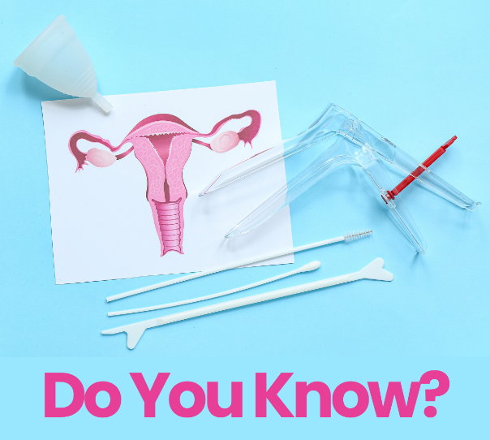

Did you know that if you feel discomfort or pain during your smear test, or you have done in the past, you can request to have a smaller speculum which is the object used to carry out the smear test.
The smaller speculum can reduce pain and make your cervical screening test more comfortable. If you do experience pain, suggest a smaller speculum next time.

Share your News

If you have anything you would like to share with us to put in the e-Bulletin, please get in touch and we will be able to include it in the future. This can include upcoming events, important information on health and social care and support around County Durham.
Email victoria.dixon@pcp.uk.net if you would like your information on the e-Bulletin.

Contact us:
Healthwatch County Durham
Whitfield House
St Johns Road
Meadowfield Industrial Estate
Durham
DH7 8XL
Freephone: 0800 3047039
Text: 07756 654218
Email: healthwatchcountydurham@pcp.uk.net
Website: www.healthwatchcountydurham.co.uk

