December 2023 News Update

Merry Christmas

All of the team would like to say thank you to everyone for your support, feedback and engagement throughout 2024. We have had lots of changes to the team due to retirements and new jobs becoming available and we have all loved being able to get involved with the amazing work going on within County Durham in health and social care. We have published 8 reports, supported 243 clients through signposting, which equates to 5620 hours.
We will continue this work into 2024 and look forward to new exciting opportunities.
We hope you all have a great festive period, however you celebrate, and the next e-Bulletin will be February 2024!
If you would like to see some highlights we have had through the year, please check out our social media channels. From 11th December, we will have a Christmas countdown celebrating some of our successes throughout the year. Facebook, LinkedIn, X, Instagram.
Over the holiday period our office will be closed between
2pm Friday 22nd December 2023 and reopen on Tuesday 2nd January 2024.
You can still email us and leave feedback via our website during this time, but please be aware you will not receive an immediate reply.
Stay safe, and have a lovely time.

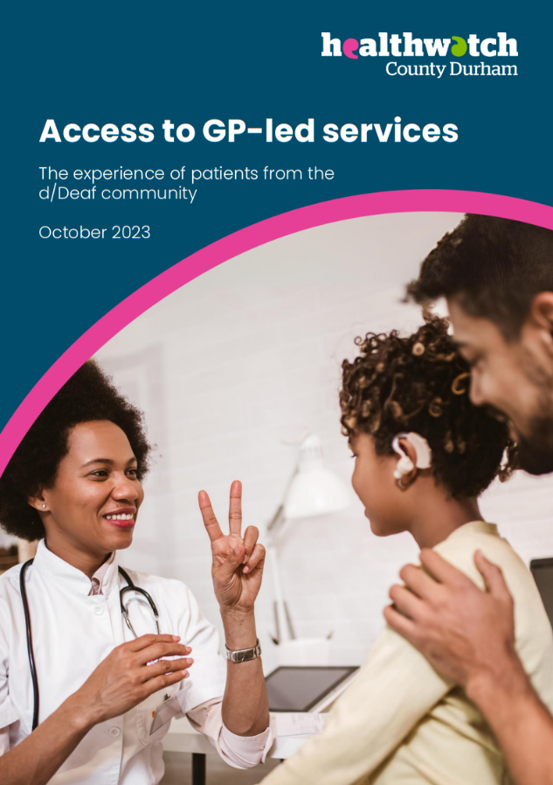
Hospital Discharge Report
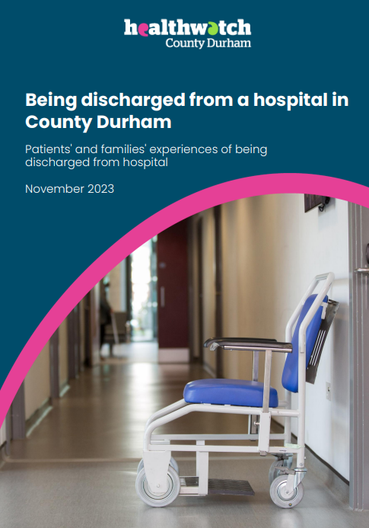
Our team have published two reports this month and they are now available to view on the website.
The first one is the Hospital Discharge report which is where we spoke to patients who had recently been discharged from hospital and their experiences. Did they have care plans in place, did they see these before being discharged, was there support in getting medication, help them get home?
We also got insight from the University Hospital of North Durham and Bishop Auckland Hospital.
The second report is Access to GP-led services, the experience of patients from the d/Deaf community. This report focuses on how the d/Deaf community access GP services, what support they currently have and what further support they need. We got feedback from both people in the D/deaf community and from practice managers in County Durham.
To read the reports please go to our website at www.healthwatchcountydurham.co.uk and click on News and Reports.
If you would like these reports in another format, please email us on healthwatchcountydurham@pcp.uk.net or phone 0800 3047039

Enter and View Report

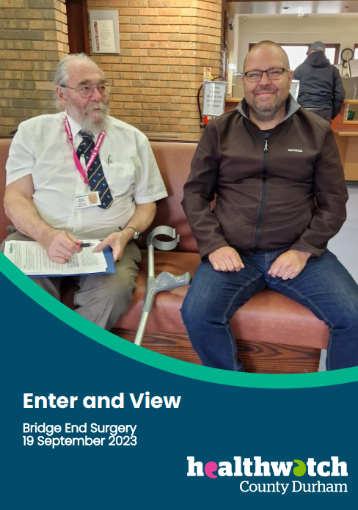
Our Enter & View Report on Bridge End Surgery has now been published.
Our trained representatives received feedback from patients on how the surgery operated. 20 individual interviews were carried out with patients during the visit and 7 were completed before the visit. It was our 5th Enter and View of the year.
We have 1 more Enter and View coming up in December and 1 planned for early next year. Watch this space for updates and the next report.
Read the Bridge End Surgery report on our website at www.healthwatchcountydurham.co.uk under news and reports.

Signposting Spotlight

We recently had a client who contacted us because she had a lump on her leg for which she was referred for an ultrasound. Following this, an urgent referral was required for her to go back in 2 weeks for an MRI. She received an appointment however the appointment was in 5 weeks. The client felt that this was too long to wait after she was told it should be an urgent referral.
We contacted her GP Practice after understanding that the referral was made under the wrong pathway. The practice was quick to investigate this and advised the patient that she had an appointment next week. The client was happy with this outcome and thanked us for our support.
We are here to make calls to any health and social care organisations on your behalf. If there is no answer, please leave a message and one of us will get back to you. You can contact us on 0800 3047039 Text 07756 654218 or email healthwatchcountydurham@pcp.uk.net

Inclusion Update

Inclusion work is progressing well, with detailed work occurring in two areas: Farming Outreach and Autism.
Farming Outreach
The Royal Agricultural Benevolent Institute’s “Big Farming Survey” published in 2021 indicated that farming people were ‘carrying’ their complaints and injuries to the detriment not only of their physical and mental health, but this could also affect the running of their farms.
Work has started, involving several public bodies and farming oriented organisations, to agree the best way to engage with farming communities and take their advice about what might stop them from getting the help they need; and then what, in their view, a solution would look like.
If you are a farming person, or if you know of someone that is, and you/they would like to have a say, please contact Tony Bentley, Engagement & Inclusion Lead, Healthwatch County Durham on 07821 650442 or tony.bentley@pcp.uk.net
Autism
We have been asking local autistic people about their experiences of visiting the GP, and any particular issues or difficulties they face in this area.
We aim to produce a document, drafted with the help of autistic people, that will help GPs and GP receptionists understand the patient’s perspective. We aim to encourage health service providers to make reasonable adjustments to improve the experience for autistic people and make appointments easier, less stressful, and get better results.
If you are autistic, or if you know someone that is, and you/they would like to have a say, please con please contact Tony Bentley, Engagement & Inclusion Lead, Healthwatch County Durham on 07821 650442 or tony.bentley@pcp.uk.net

Durham County Carers - Support for Unpaid Carers

Durham County Carers (DCC) is the primary Carer support service in County Durham and Darlington. We invited a couple of their representatives along to our last Healthwatch County Durham Volunteer meeting where they gave an overview of their services. They support unpaid Carers over the age of 18, who in turn support people living in County Durham & Darlington.
If you have any questions or issues you'd like to raise either talk to them directly, as below, or we are happy to collate and pass on to them on your behalf.
You can also visit their website for lots of information on how they can support you: https://dccarers.org/

Contact Emergency Services by text message
Did you know that if you were hard of hearing, d/Deaf or deafblind you can contact emergency services by SMS text messaging all you need to do is register.
Follow these simple steps to set it up.
Step 1: Text ‘REGISTER’ on your mobile and send it to 999.
Step 2: You will receive a text containing the terms and conditions which you simply need to text 'YES' back to.
You will then be all set up to use this service.

Companionship Cafe

Neurodiversity Peer Support Group
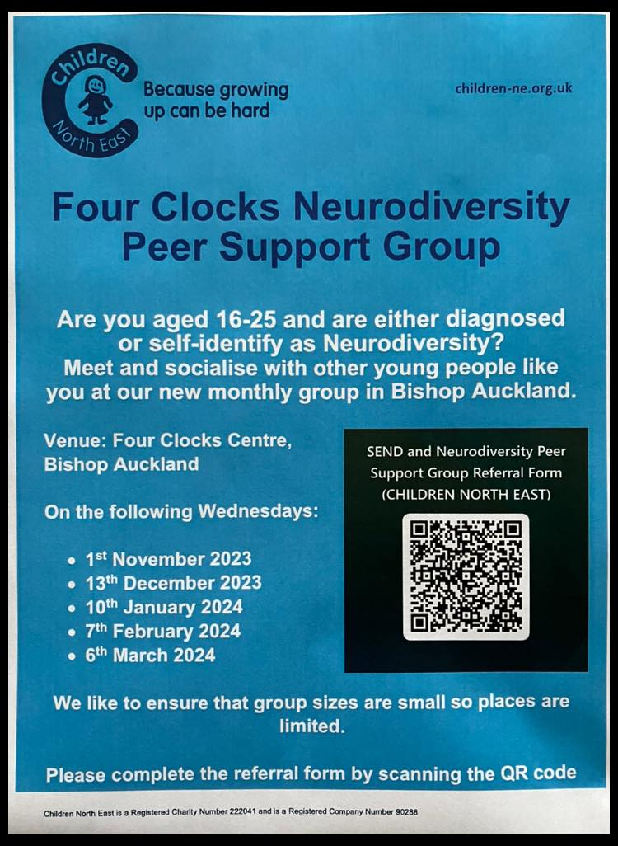

There is still time to join the Four Clocks Neurodiversity Peer Support Group, they have monthly meetings with one on 13th December. Scan the QR code on the poster to book into the group.

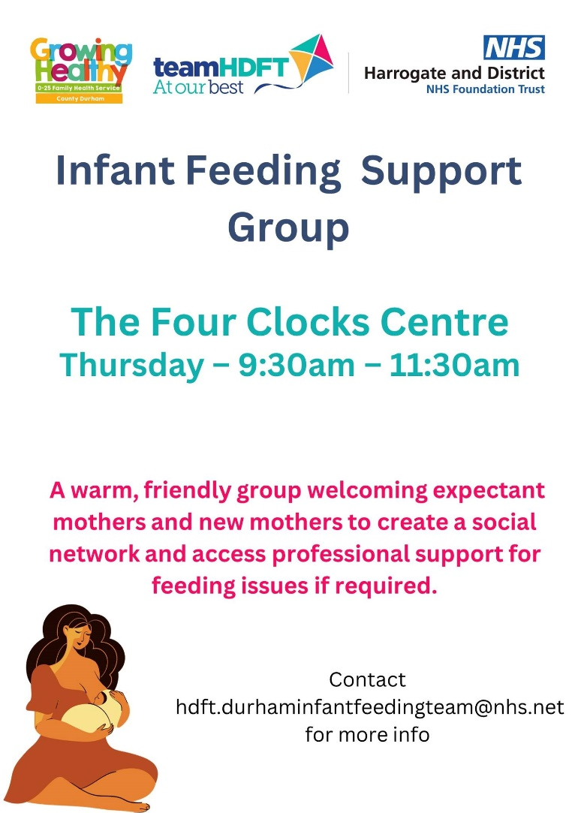

Four Clocks also have an Infant Feeding Support Group which is for mothers to create a social network for support and share their infant feeding issues with one another. Contact hdft.durhaminfantfeedingteam@nhs.net for more information.

Winter Wellness Groups
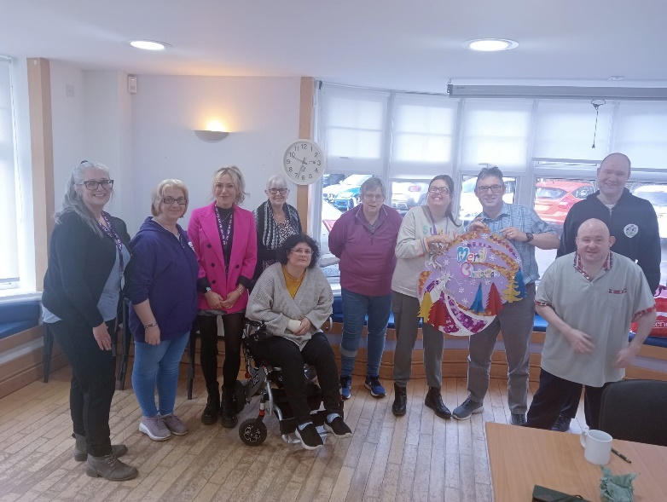

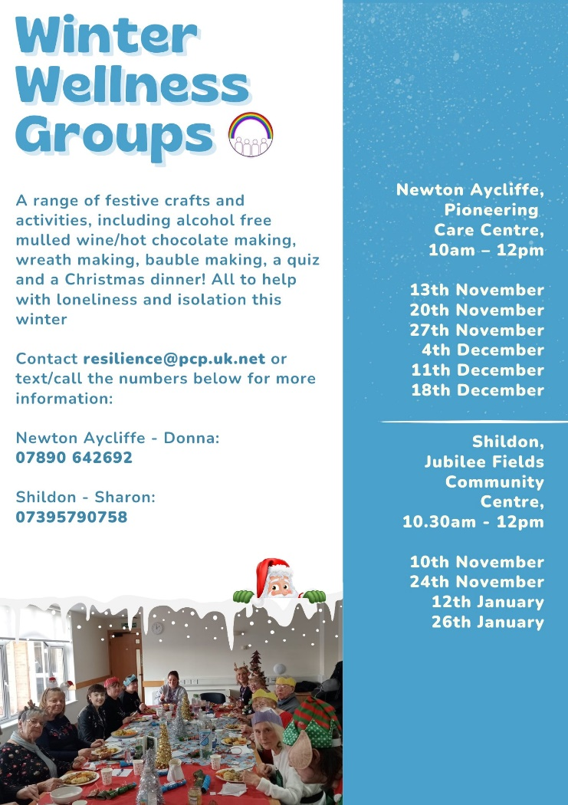
The Winter Wellness Groups have already started but there is still time to join in with their sessions. They have been busy crafting with a Christmassy edge. You can just turn up to the sessions, but if you would like more information please get in touch with the Resilience team on resilience@pcp.uk.net or phone the relevant numbers for your preferred area above.

Mental Health Support Survey

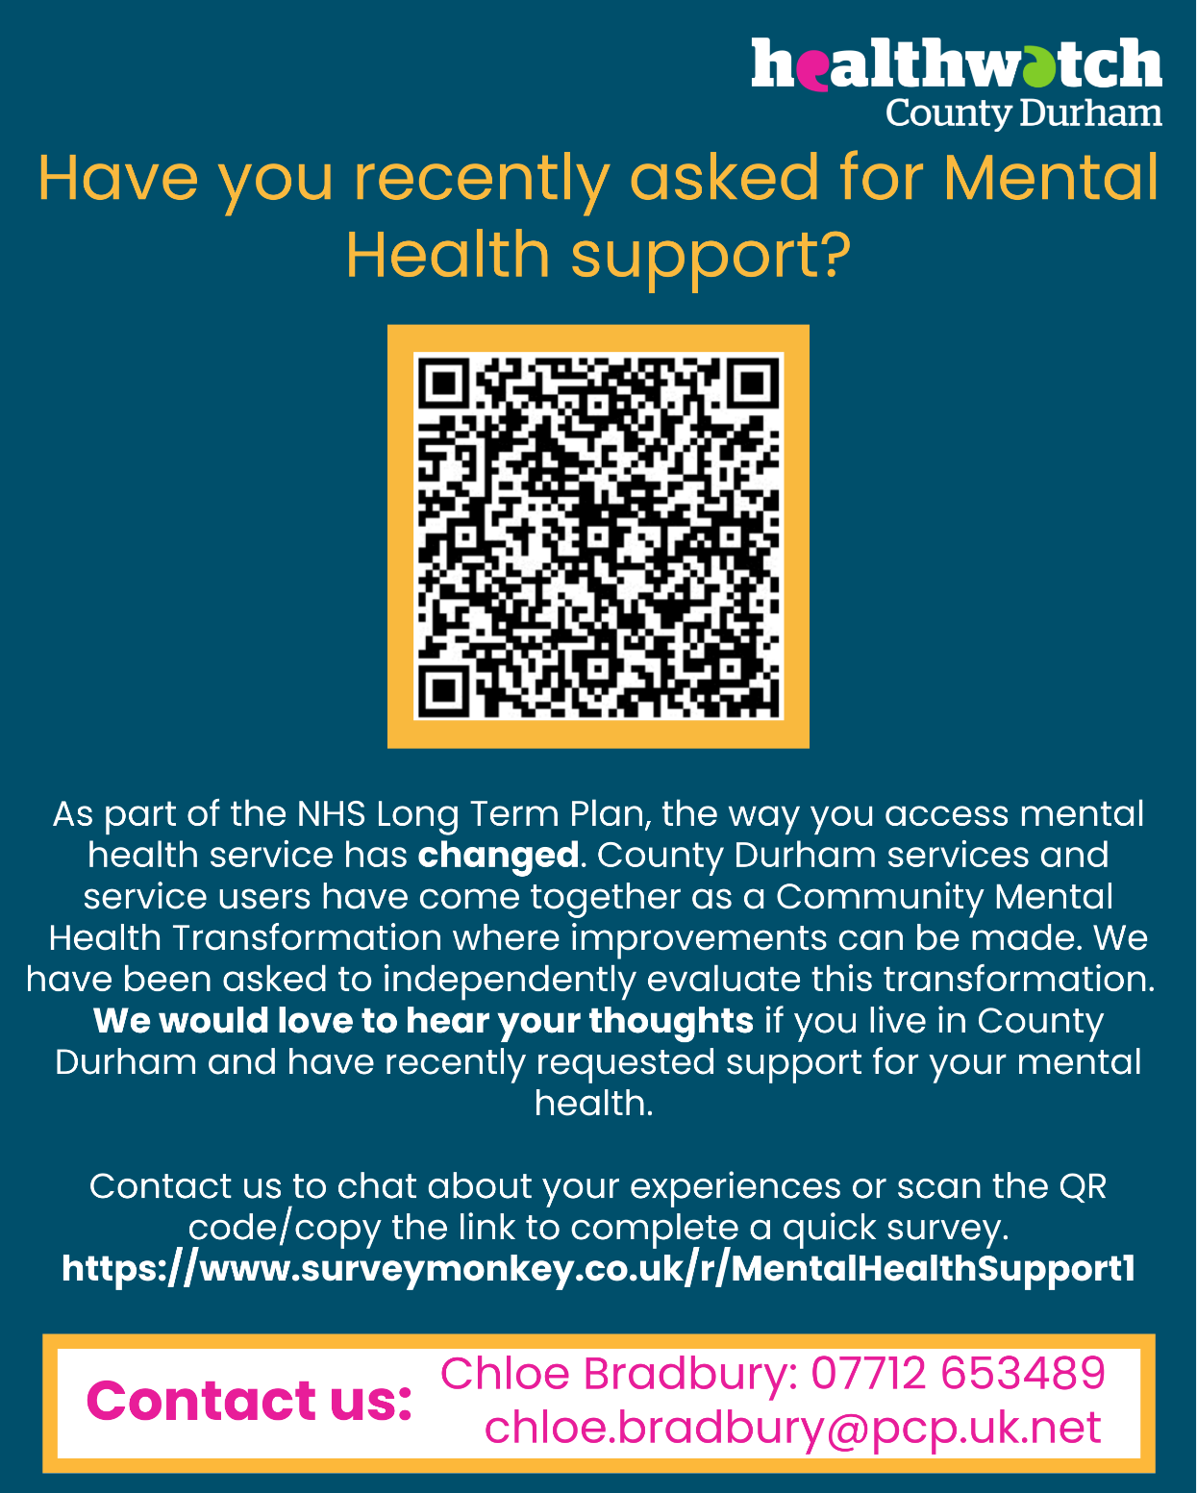
To access the survey please visit https://www.surveymonkey.co.uk/r/MentalHealthSupport1

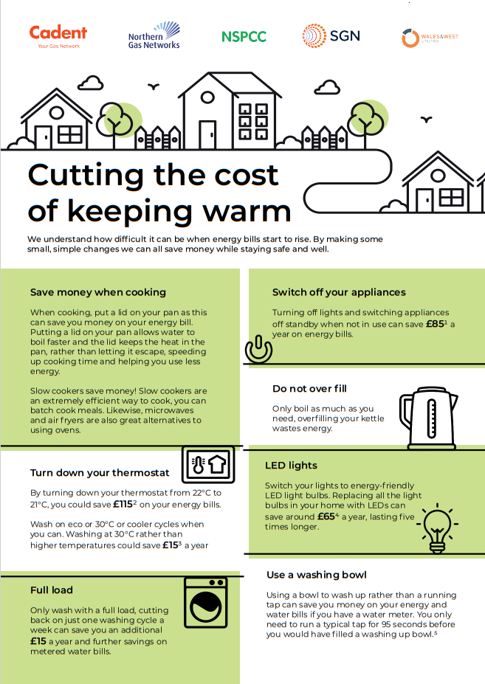
Help cut the cost of energy bills this winter
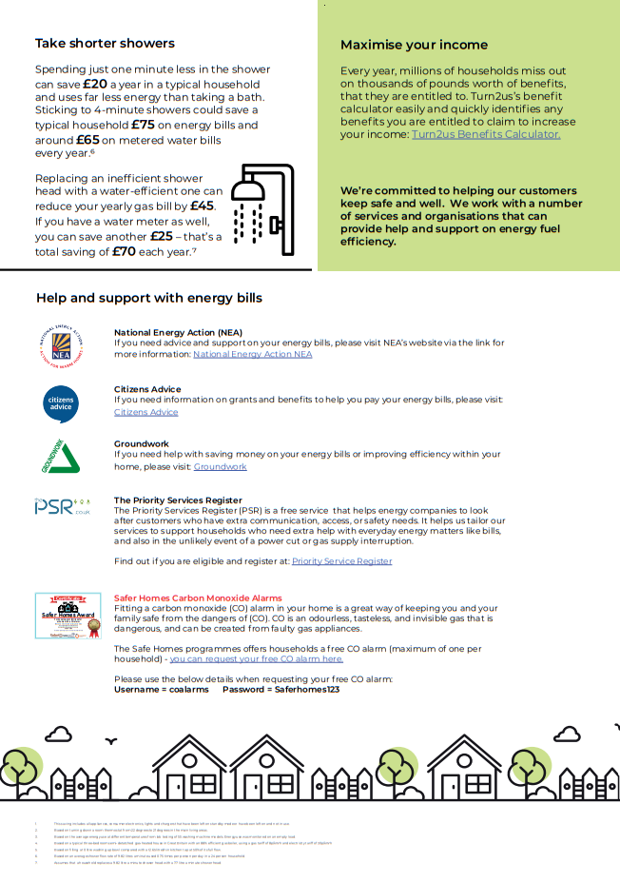

Support Group for Parents with Children who experience Difficulties

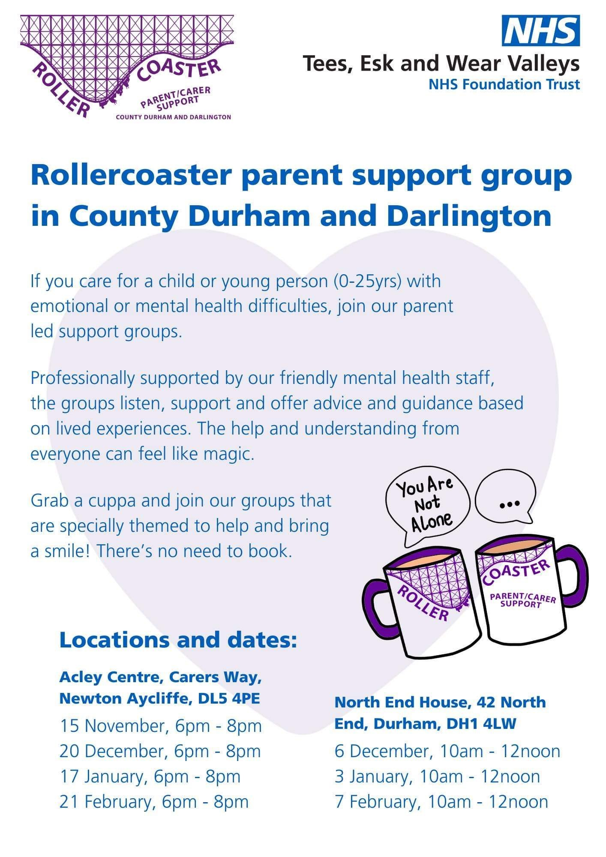

We are now on LinkedIn

Give us a follow on LinkedIn at https://www.linkedin.com/company/healthwatch-co-durham/

Share your news!

If you have anything you would like to share with us to put in the e-Bulletin, please get in touch and we will be able to include it in the future. This can include upcoming events, important information on health and social care and support around County Durham.
Email victoria.dixon@pcp.uk.net if you would like your information on the e-Bulletin.
Contact us:
Healthwatch County Durham
Whitfield House
St Johns Road
Meadowfield Industrial Estate
Durham
DH7 8XL
Freephone: 0800 3047039
Text: 07756 654218
Email: healthwatchcountydurham@pcp.uk.net
Copyright © 2021 Healthwatch County Durham, All rights reserved.
Healthwatch County Durham is hosted by Pioneering Care Partnership
Registered Charity Number: 1067888
Company Limited by Guarantee Number: 3491237
Pioneering Care Partnership is data controller for all of the personal data that you provide us with. Any issues relating to the processing of personal data by or on behalf of Healthwatch County Durham may be addressed to: People and Impact Manager, Pioneering Care Partnership, Carers Way, Newton Aycliffe, DL5 4SF, or call 01325 321234

https://www.facebook.com/healthwatchcountydurham/
https://twitter.com/HWCountyDurham
https://www.healthwatchcountydurham.co.uk/
https://www.instagram.com/healthwatchcodurham/
https://www.linkedin.com/company/healthwatch-co-durham/

